=====================================================

|| Functional and Performance Test For Marvin EBAY ||

|| P/N TLM132XX501 S/N:001 ||

|| Date:19/02/2018 Time: 11:55 Test-Conductor: ||

|| Tester P/N yyyy-yyyyyy-yyyy S/N: ||

|| POWER SUPPLY P/N xxxxx ||

|| ||

|| ||

=====================================================

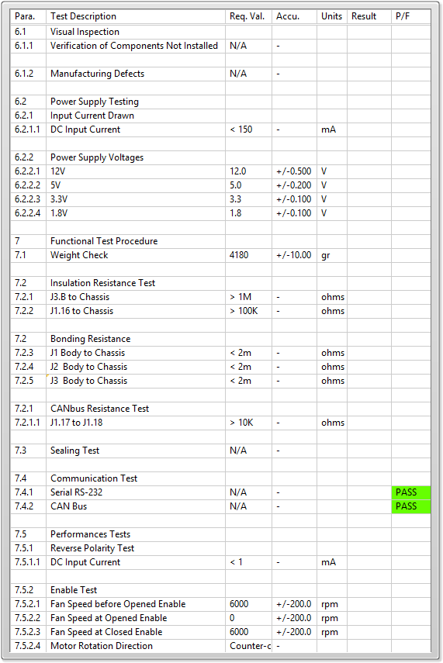

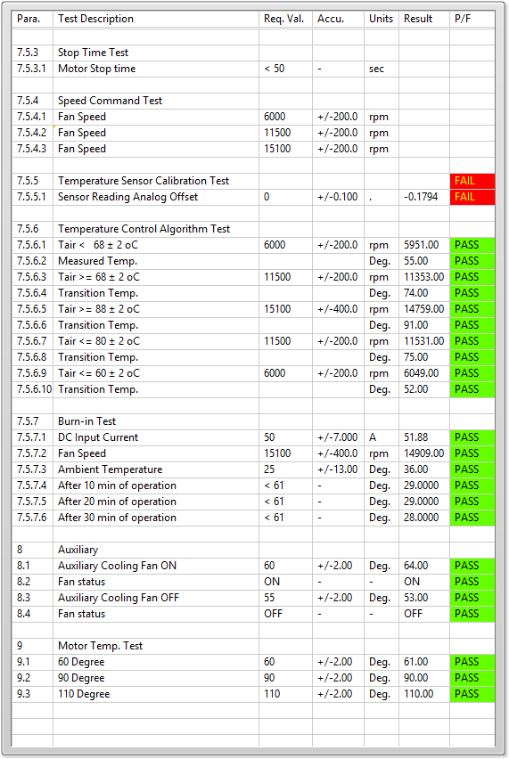

Summery of Results (Fails Only) : 7.5.5 FAIL !

7.5.5.1 FAIL !

General result:

Test-Operator:____ _________ Q.A.:__________________________